**Traverse a Tree - Introduction**

* [Pre-order Traversal](https://leetcode.com/explore/learn/card/data-structure-tree/134/traverse-a-tree/992/#pre-order-traversal)
* [In-order Traversal](https://leetcode.com/explore/learn/card/data-structure-tree/134/traverse-a-tree/992/#in-order-traversal)
* [Post-order Traversal](https://leetcode.com/explore/learn/card/data-structure-tree/134/traverse-a-tree/992/#post-order-traversal)
* [Recursive or Iterative](https://leetcode.com/explore/learn/card/data-structure-tree/134/traverse-a-tree/992/#recursive-or-iterative)

Pre-order Traversal

Pre-order traversal is to visit the root first. Then traverse the left subtree. Finally, traverse the right subtree. Here is an example:

**Note:** in the following animation, the **highlighting** in red indicates that we return from the visit of the node. The order of the visit is indicated on the array right below the binary tree.

1 / 19

In-order Traversal

In-order traversal is to traverse the left subtree first. Then visit the root. Finally, traverse the right subtree.

Let's do in-order traversal together:

1 / 22

Typically, for binary search tree, we can retrieve all the data in sorted order using in-order traversal. We will mention that again in another card([Introduction to Data Structure - Binary Search Tree](https://leetcode.com/explore/learn/card/introduction-to-data-structure-binary-search-tree/)).

Post-order Traversal

Post-order traversal is to traverse the left subtree first. Then traverse the right subtree. Finally, visit the root.

Here is an animation to help you understand post-order traversal:

1 / 19

It is worth noting that when you delete nodes in a tree, deletion process will be in post-order. That is to say, when you delete a node, you will delete its left child and its right child before you delete the node itself.

Also, post-order is widely use in mathematical expression. It is easier to write a program to parse a post-order expression. Here is an example:

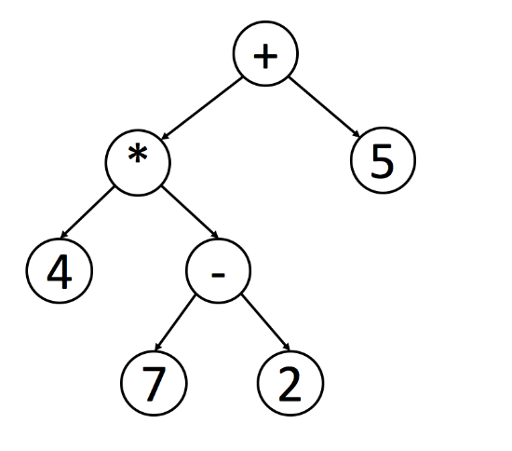

You can easily figure out the original expression using the inorder traversal. However, it is not easy for a program to handle this expression since you have to check the priorities of operations.

If you handle this tree in postorder, you can easily handle the expression using a stack. Each time when you meet a operator, you can just pop 2 elements from the stack, calculate the result and push the result back into the stack.

Recursive or Iterative

Try to practice the three different traversal methods in our after-article exercise. You might want to implement the methods recursively or iteratively. Implement both recursion and iteration solutions and compare the differences between them.